Project Design Phase-II
Data Flow Diagram & User Stories

Date | [DD Month YYYY]
Team ID | [Team ID]
Project Name | Automated Network Request Management in ServiceNow
Maximum Marks | 4 Marks

Data Flow Diagrams:
A Data Flow Diagram (DFD) is a traditional visual representation of the information flows within a system. A neat and clear DFD can depict the right amount of the system requirement graphically. It shows how data enters and leaves the system, what changes the information, and where data is stored.
DFD Level 0 — Context Diagram
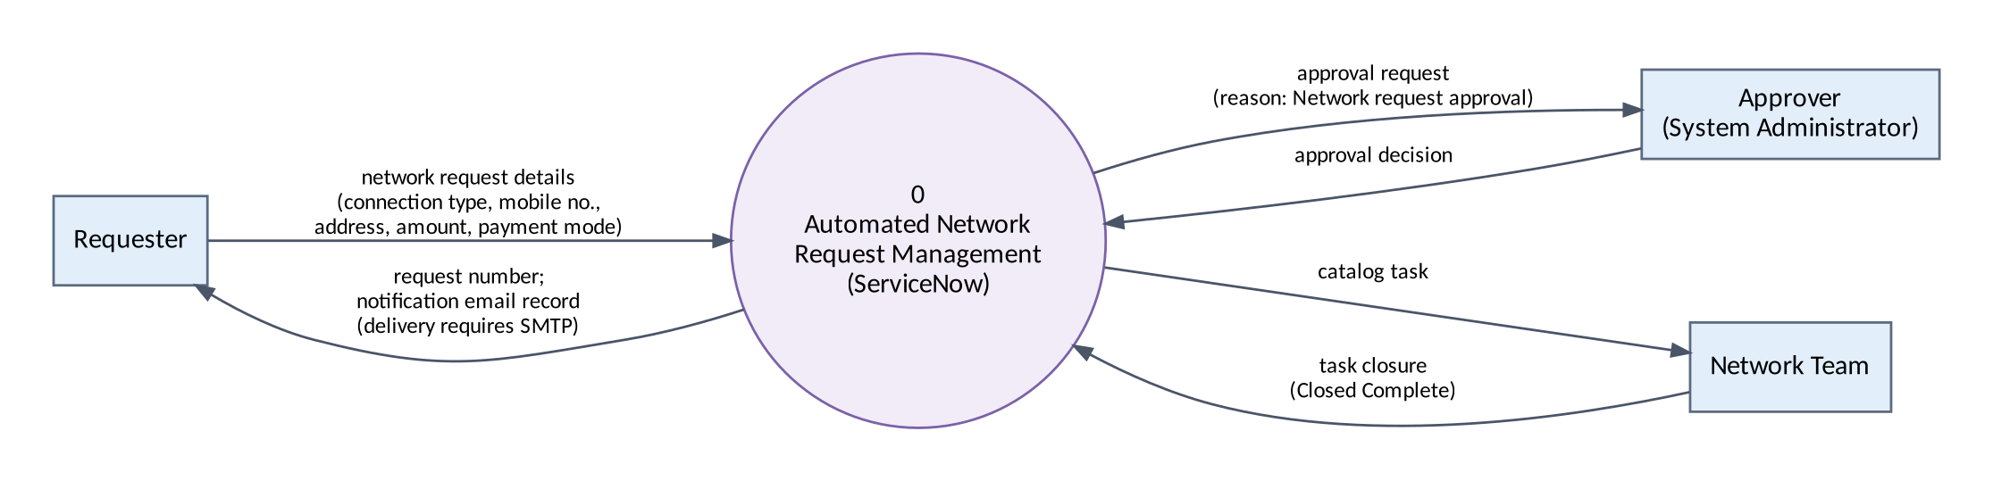
Figure 1: DFD Level 0 — Automated Network Request Management

DFD Level 1 — Processes and Data Stores
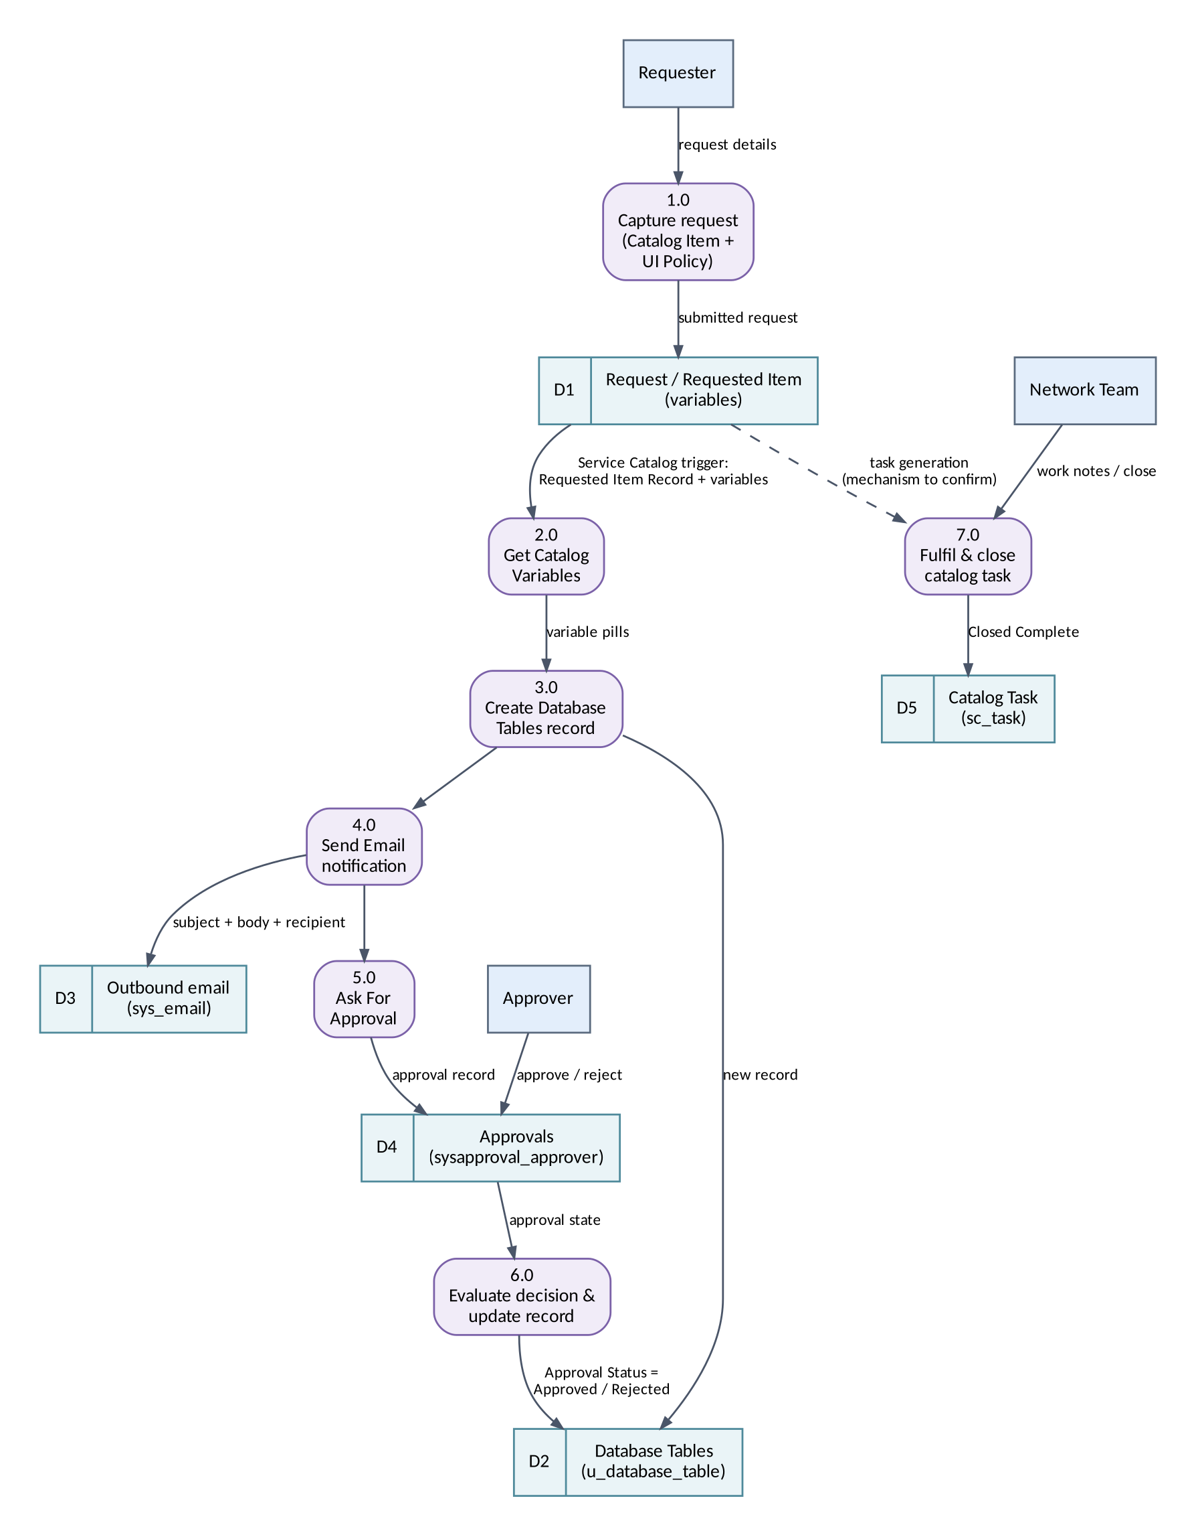
Figure 2: DFD Level 1 — processing inside ServiceNow
Notes on the flows. D1–D5 are ServiceNow tables. The flow uses a Service Catalog trigger: requesting the item passes the Requested Item Record to Get Catalog Variables, and Create Record writes the request to D2. Known defect: the stored values are variable names instead of the submitted values (BG-03). The way the catalog task (D5) is generated is not covered by the evidence and is shown dashed. The email record (D3) is generated (send-ready), but external delivery requires SMTP, which is not configured.

User Stories
Use the below template to list all the user stories for the product.
User Type | Functional Requirement (Epic) | User Story Number | User Story / Task | Acceptance criteria | Priority | Release
Requester | Catalog Item Setup | USN-1 | As a requester, I can find the Network Request item in the Service Catalog under the Network category. | Item is available (Network > Network Request, 'Network Services Request') and opens a request form. | High | Sprint-1
Requester | Catalog Item Setup | USN-2 | As a requester, I can enter Requested For, Mobile Number, Type of Connection, Total Amount, Mode of Payment and Address and submit the request. | All variables are displayed and a request number (e.g. REQ0010004) is generated on submission. | High | Sprint-1
Requester | Catalog Item Setup | USN-3 | As a requester, my Email and User Name are filled automatically from the Requester Information variable set. | Email and User Name populate from the referenced user. Phone Number population requires verification. | Medium | Sprint-1
Requester | Catalog Item Setup | USN-4 | As a requester, I see the 'Enter your existing id' field only when I choose an Existing connection. | Field is visible for Existing and hidden for New (UI Policy 'Show existing ID field'). | High | Sprint-1
Administrator | Data Model | USN-5 | As an administrator, each network request is stored in the Database Tables (u_database_table) table. | A DAT-numbered record holds the request details and an Approval Status. | High | Sprint-1
Approver | Data Model | USN-6 | As an approver, I can see the approval records that belong to a Database Tables record. | 'Approval Request' relationship lists approvals whose source_table and document_id match the record. | Medium | Sprint-1
Administrator | Flow Automation | USN-7 | As an administrator, the Network Request Automation flow starts automatically when the Network Request item is requested and retrieves the catalog variables. | Service Catalog trigger fires and Get Catalog Variables completes. | High | Sprint-2
Administrator | Flow Automation | USN-8 | As an administrator, the flow creates a Database Tables record from the submitted catalog values. | Each field holds the value submitted on the form (currently failing — BG-03). | High | Sprint-2
Requester | Notification | USN-9 | As a requester, I am notified that my request has been received and is pending approval. | Email record is generated with subject 'Network Request Received - Pending Approval' and the configured body. External delivery needs SMTP. | Medium | Sprint-2
Approver | Approval | USN-10 | As an approver, I receive an approval request for every new network request. | Approval is requested with reason 'Network request approval', rule 'Approve when anyone approves'. | High | Sprint-2
Administrator | Approval | USN-11 | As an administrator, the request status is updated to Approved or Rejected according to the decision. | Approved branch verified in a test run. Rejected branch to be tested. | High | Sprint-2
Network Team | Fulfilment | USN-12 | As a Network Team member, I can work on and close the catalog task for the request. | Catalog task (e.g. SCTASK0010008) can be set to Closed Complete. | Medium | Sprint-3
Administrator | Testing & Evidence | USN-13 | As the project team, we test the end-to-end process and capture evidence for each test case. | Every test case has a recorded status and evidence; untested cases are explicitly marked. | High | Sprint-3
Project Team | Documentation & Demo | USN-14 | As the project team, we prepare documentation, a demonstration video and a GitHub submission. | Phase documents completed; video recorded; GitHub link submitted on SkillWallet. | Medium | Sprint-3

